How to copy data from adls to sql database

1. Create adls storage account
2. Create container
3. Create directory
4. Upload csv file
5. Then create data factory
6. Go to data factory
7. Create linked list 1 to connect to adls like previously

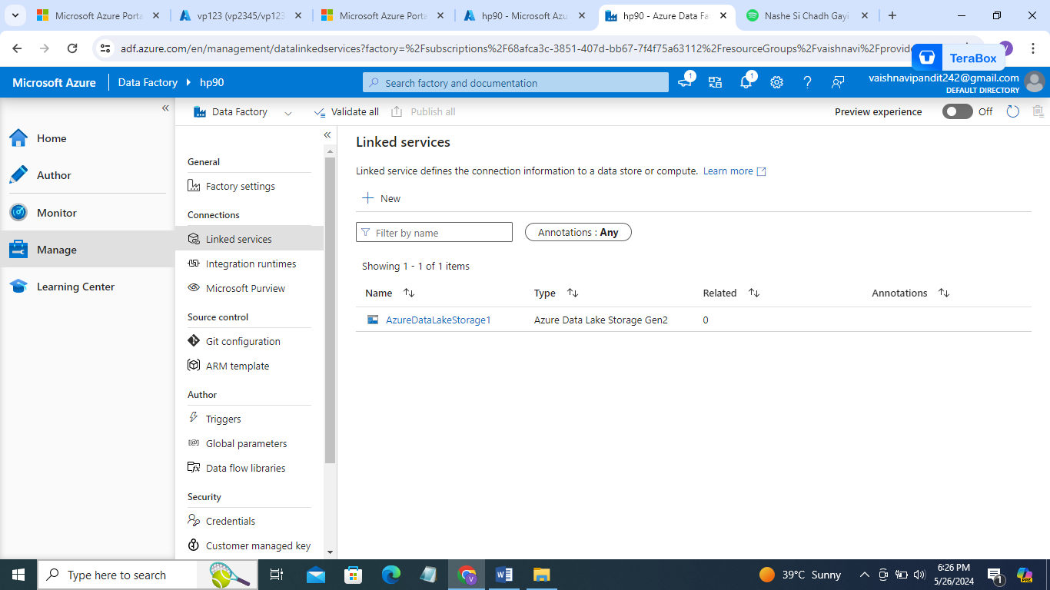

1. Now create linked service for the sql database

Go to create

Go to sql database

1. Now continue write server name, database name, username, password

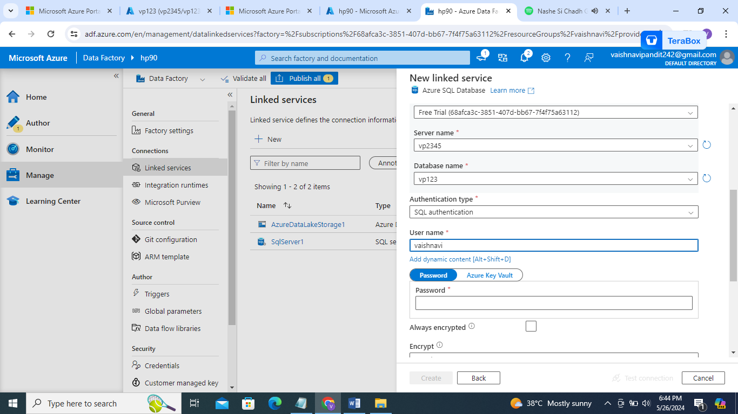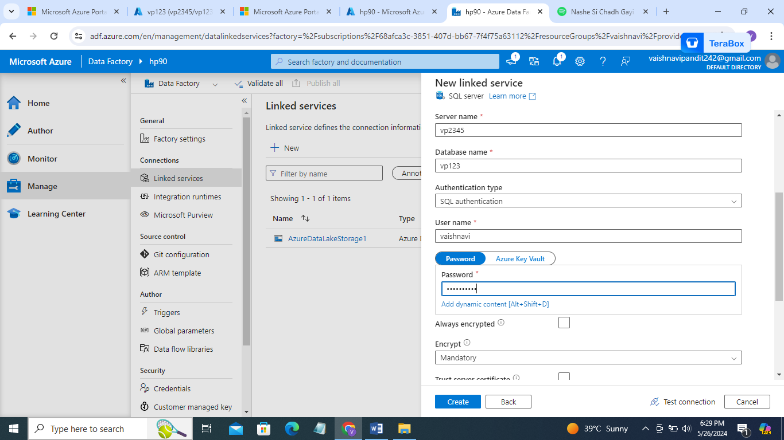

1. Now create dataset 1 for adls storage and dataset2 for the sql server

Select adls

Go to csv

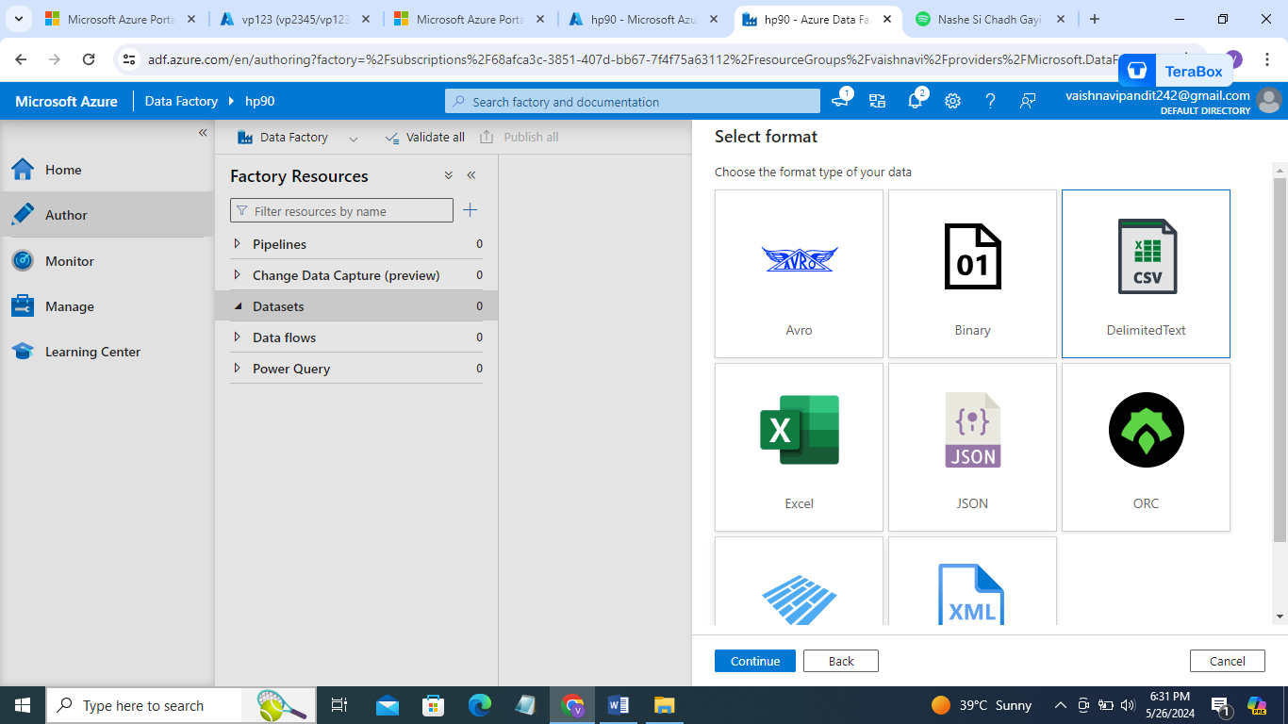

1. Select linked service and path

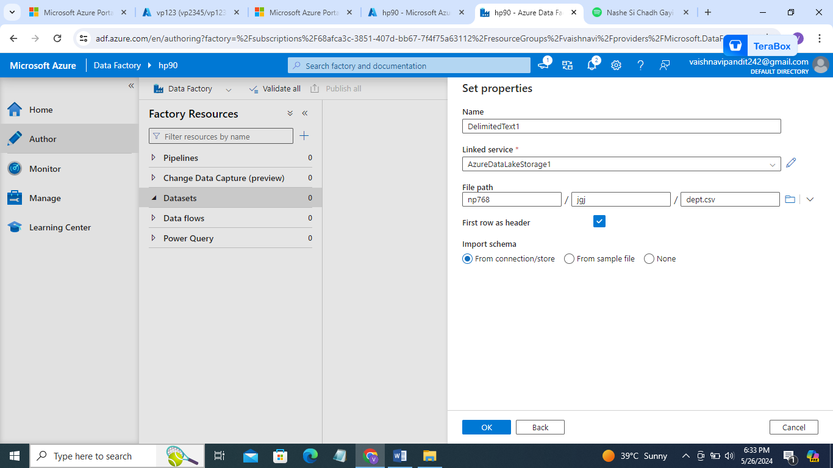

1. Create dataset2 to the sql database
2. Create dataset select sql server

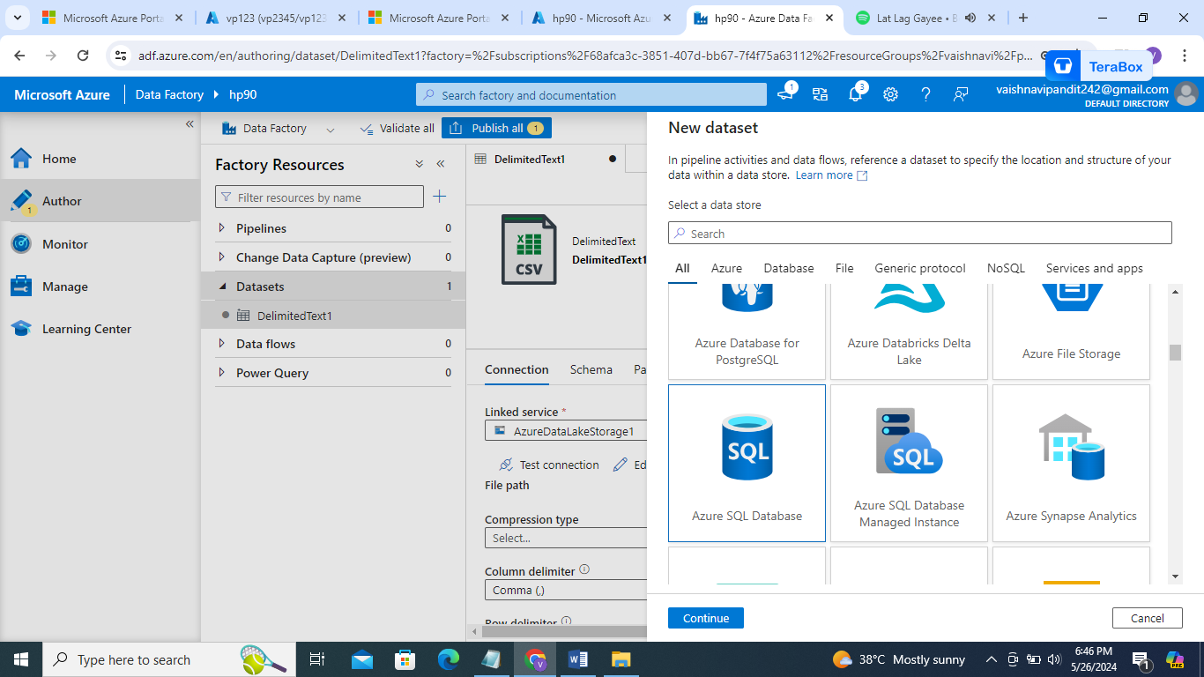

1. Select linked service and table name manually

You will find table name in query editor

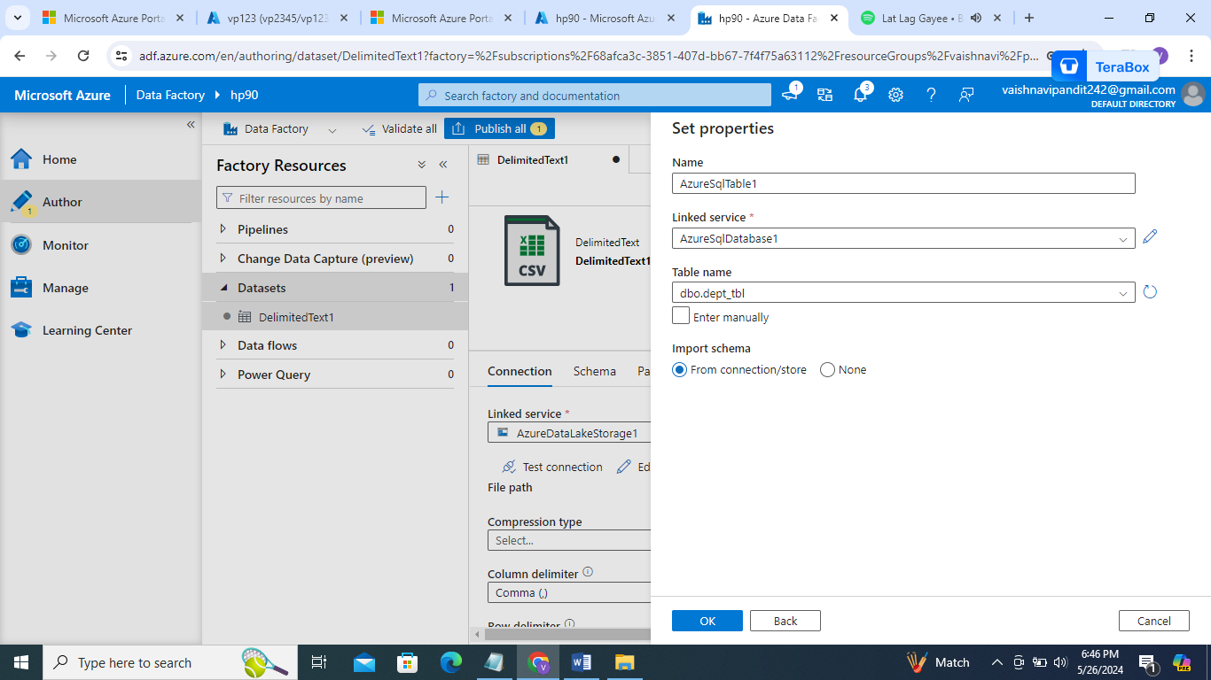

1. Now create pieline
2. Create copy activity
3. In source add dataset 1
4. In sink add dataset 2
5. 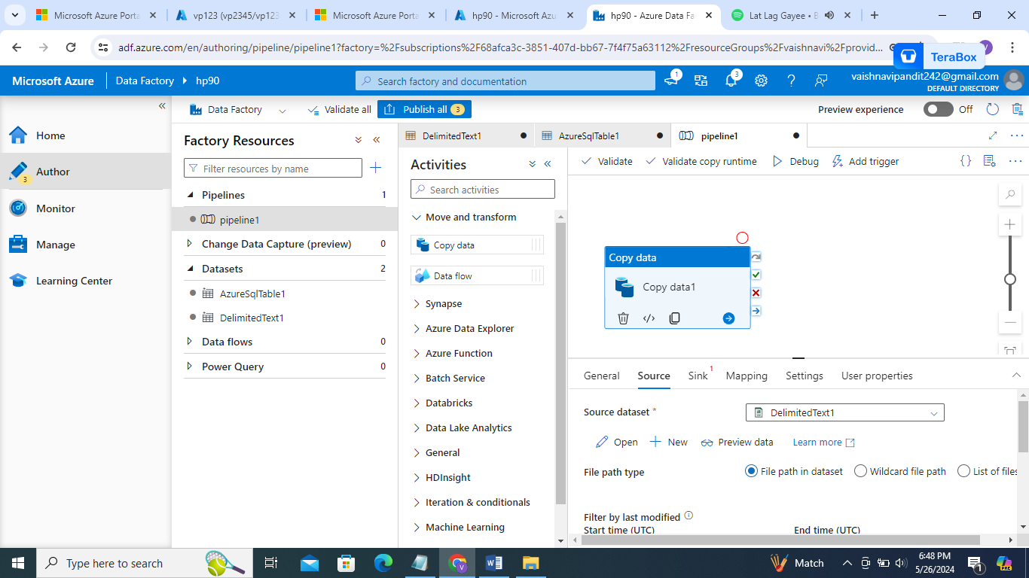
6. 